1.Create Database and Collection
use payrollDB
db.createCollection("employees")
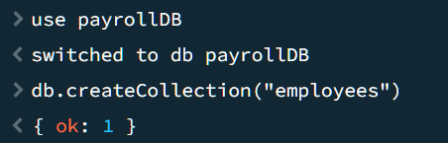
2. Insert Sample Data
db.employees.insertMany([
{ emp_id: "E101", name: "John", department: "HR", basic_salary: 45000, hra: 8000, allowances: 3000 },
{ emp_id: "E102", name: "Mary", department: "IT", basic_salary: 60000, hra: 10000, allowances: 5000 },
{ emp_id: "E103", name: "Sam", department: "Finance", basic_salary: 55000, hra: 9000, allowances: 4000 },
{ emp_id: "E104", name: "David", department: "IT", basic_salary: 65000, hra: 11000, allowances: 7000 },
{ emp_id: "E105", name: "Rose", department: "HR", basic_salary: 48000, hra: 8500, allowances: 3500 }
])
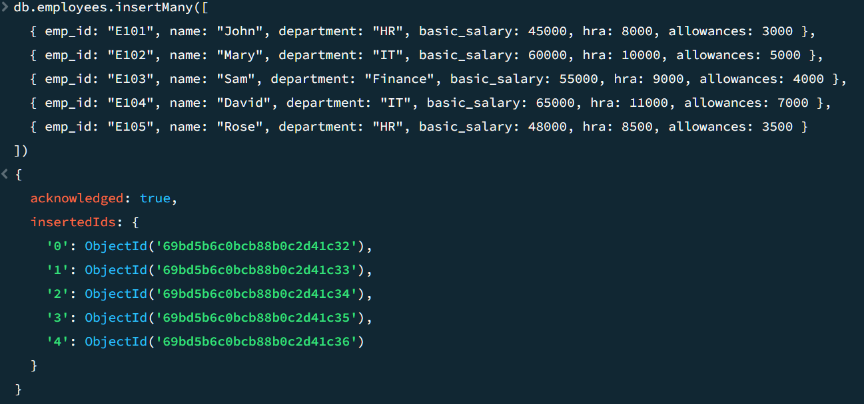
3.Apply Aggregate Queries
i) Total Salary of Each Employee
db.employees.aggregate([{ $project: { name: 1, department: 1, total_salary: { $add: ["$basic_salary", "$hra", "$allowances"] } } }])
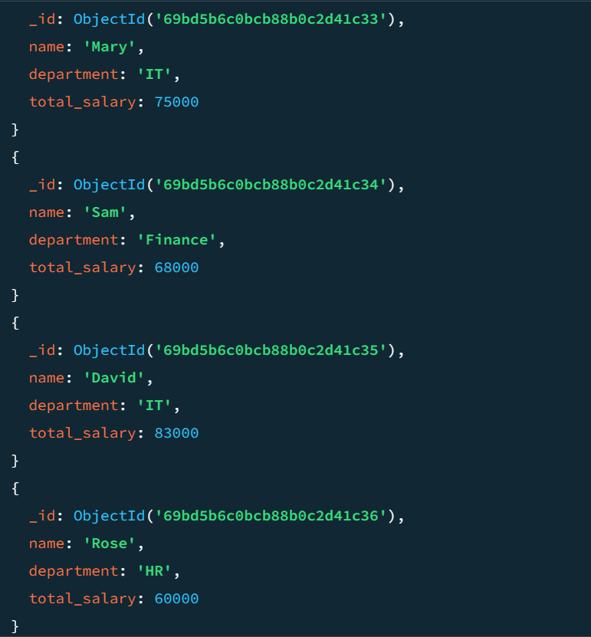
ii) Total Salary Paid by Organization
db.employees.aggregate([{ $group: { _id: null, total_paid: { $sum: { $add: ["$basic_salary", "$hra", "$allowances"] } } } }])
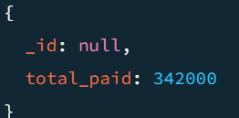
iii) Department-wise Average Salary
db.employees.aggregate([{ $group: { _id: "$department", avg_salary: { $avg: "$basic_salary" } } }])
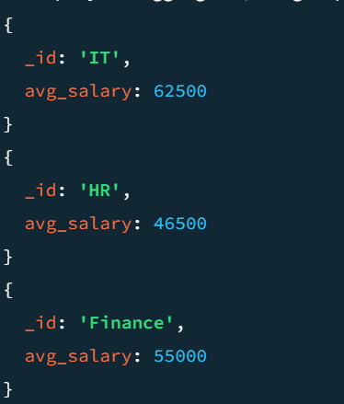
iv) Highest & Lowest Salary in Each Department
db.employees.aggregate([{ $group: { _id: "$department", max: { $max: "$basic_salary" }, min: { $min: "$basic_salary" } } }])
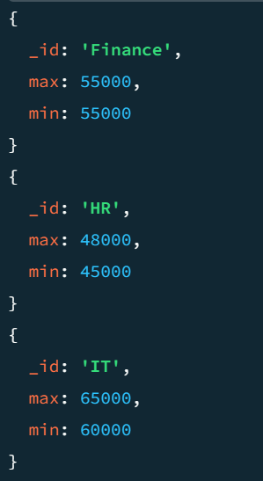
v) Count Employees in Each Department
db.employees.aggregate([{ $group: { _id: "$department", emp_count: { $sum: 1 } } }])
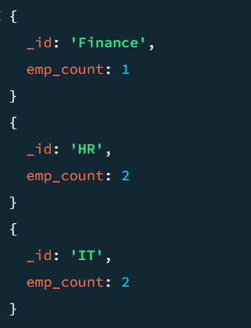
vi) Sort Employees by Salary (Descending)
db.employees.aggregate([{ $sort: { basic_salary: -1 } }])
